Preparation of Extended Abstract for ASC Student Paper Competition

First A. Author, Student Member, IEEE, Second B. Author, Jr., and Third C. D. Author, Fellow, IEEE
XYZ University, City, State/Region, Mail/Zip Code, Country (authors' affiliation(s) listed here in 12 point Times font – use a second line if necessary)

Abstract—These instructions give you guidelines for preparing extended abstracts for entering the Applied Superconductivity Conference Student Paper Contest. The extended abstract is limited to 2 pages plus 1 optional page for references. Use this document as a template if you are using Microsoft Word 6.0 or later. Otherwise, use this document as an instruction set. This template is useful for estimating the length of your paper, but its use is optional. Full names of authors are preferred, but initials may be used instead. Put a space between authors’ initials. Department names are optional in the affiliations. Do not give street addresses in the affiliations (except for authors with no institutional affiliation). Define all symbols used in the abstract, and once again in the text. Do not cite references in the abstract.

Introduction
T
his document is a template for preparing extended abstracts for the Applied Superconductivity Conference (ASC) Student paper Contest. This template is intended for Microsoft Word versions 6.0 or later. Use of this document as a template is optional. If you elect not to use this template, please remember that you must still adhere to the general guidelines embodied in this document concerning, but not limited to, font size, margin size, page limits, etc. Up to six finalists will be chosen by a panel of judges in each of three submission categories: Large-scale, materials, and Electronics. The two-page extended abstract is intended to describe the authors’ work in sufficient detail to allow its evaluation by the panel. Only references are allowed to appear on an optional third page. Authors may find the IEEE Author Digital Toolbox [1] to be a useful general resource.

Qualifications and Eligibility
For the purpose of the entering the ASC contest, a student is considered to be an individual who has been a full-time student of an accredited college or university during the time the work was performed. There is no age limit. Ph.D. students are eligible. Post-doctoral researchers are not considered students and are not eligible. The student need not be an IEEE Student Member to participate in this contest. A letter will be required from the student’s primary advisor indicating that the work presented in the paper was done primarily by the student contestant and performed while he/she was a student. This letter should also state that the contributions by other co-authors are secondary. The submitting student must be the first author and the presenter at the designated session. Multiple submissions are accepted.

Submission
Prepare the extended abstract and obtain a letter from your primary advisor. Submit your abstract to the ASC’18 abstract submission site by the submission deadline (March 21, 2018). During abstract submission, indicate that you wish to participate in the Student Paper Contest. Submit your 2-page Extended Abstract and your advisor’s letter along with your abstract by March 21, 2018. Extended abstracts will not be accepted without your advisor’s letter.

Text Formatting
Using 8.5 x 11-inch paper, the top and bottom margins are 0.75 inch, and the left and right margins are
0.65 inch. Except for Title, Authors and Affiliations, use a double column format. The column width is 3.5 inches and the column spacing is 0.2 inch.
Each major section begins with a Heading in 10 point Times font centered within the column and numbered using Roman numerals (except for Acknowledgement and References), followed by a period, a single space, and the title using an initial capital letter for each word. The remaining letters are in small capitals. The paragraph description of the section heading line should be set for 12 points before, and 4 points after. For the body of your paper, use 10-point Times font and set your line spacing at "exactly 12 points" with 0 points before and after. Indent each paragraph by 0.125 inches.

Major Subsections
As shown, denote subsections with left justified 10-point Times Italic. Order them with capitalized alphabetic characters (A, B,...). Follow the letter designation with a period, a single space, and then the subsection title capitalizing the first letter of each word.

Equations
If you are using Word, use either the Microsoft Equation Editor or the MathType add-on (http://www.mathtype.com) for equations in your paper (Insert > Object > Create New > Microsoft Equation or MathType Equation). “Float over text” should not be selected.
Number equations consecutively with equation numbers in parentheses flush with the right margin, as in (1). First use the equation editor to create the equation. Then select the “Equation” markup style. Press the tab key and write the equation number in parentheses. To make your equations more compact, you may use the solidus ( / ), the exp function, or appropriate exponents. It is a generally a good idea to use exponents with negative values and parentheses to avoid ambiguities in denominators created by the solidus symbol. Be sure that the symbols in your equation have been defined before the equation appears or immediately following it. Punctuate equations when they are part of a sentence, as in

(1)

Italicize symbols (T might refer to temperature, but T is the unit tesla). Refer to “(1),” not “Eq. (1)” or “equation (1),” except at the beginning of a sentence: “Equation (1) is ... .” Please try to confine equations to one column width and break equations at appropriate algebraic symbols.

Figures
Figures should utilize as much of the column width as possible in order to maximize legibility. Use a sans serif font, such as Helvetica or Arial. Helvetica and Arial are larger and much easier to read than Times. Using 8- to 10-point Helvetica usually results in a legible figure. Do not use any font smaller than 8-point! It must be legible. When referring to a figure, use the abbreviation Fig. followed by its number. Place figure captions directly below each figure. Do not put captions in separate text boxes linked to the figures. Instead, if you choose to use a text box, incorporate the electronic graphic file and the text caption together in a single text box (as is done in this document).
Within Microsoft Word there are several options for placing figures within your paper. Often the easiest is to insert them between existing paragraphs allowing the figures to remain in that relative position. The paragraph description where the figure is inserted must be set to "single" spacing rather than "exactly 12 points" in order to allow the line to autoscale in height to display the entire figure. Some disadvantages of this approach are that you don't have total flexibility in placing figures, and that the figures will move as text is inserted or deleted in any part of the document before the figure. If you elect to use this approach, it is recommended that you nearly complete the editing of your text before inserting any figures. Remember to allow room for them, however. Then begin inserting figures starting from the beginning of your document. Do not lump all figures at the end of the paper!
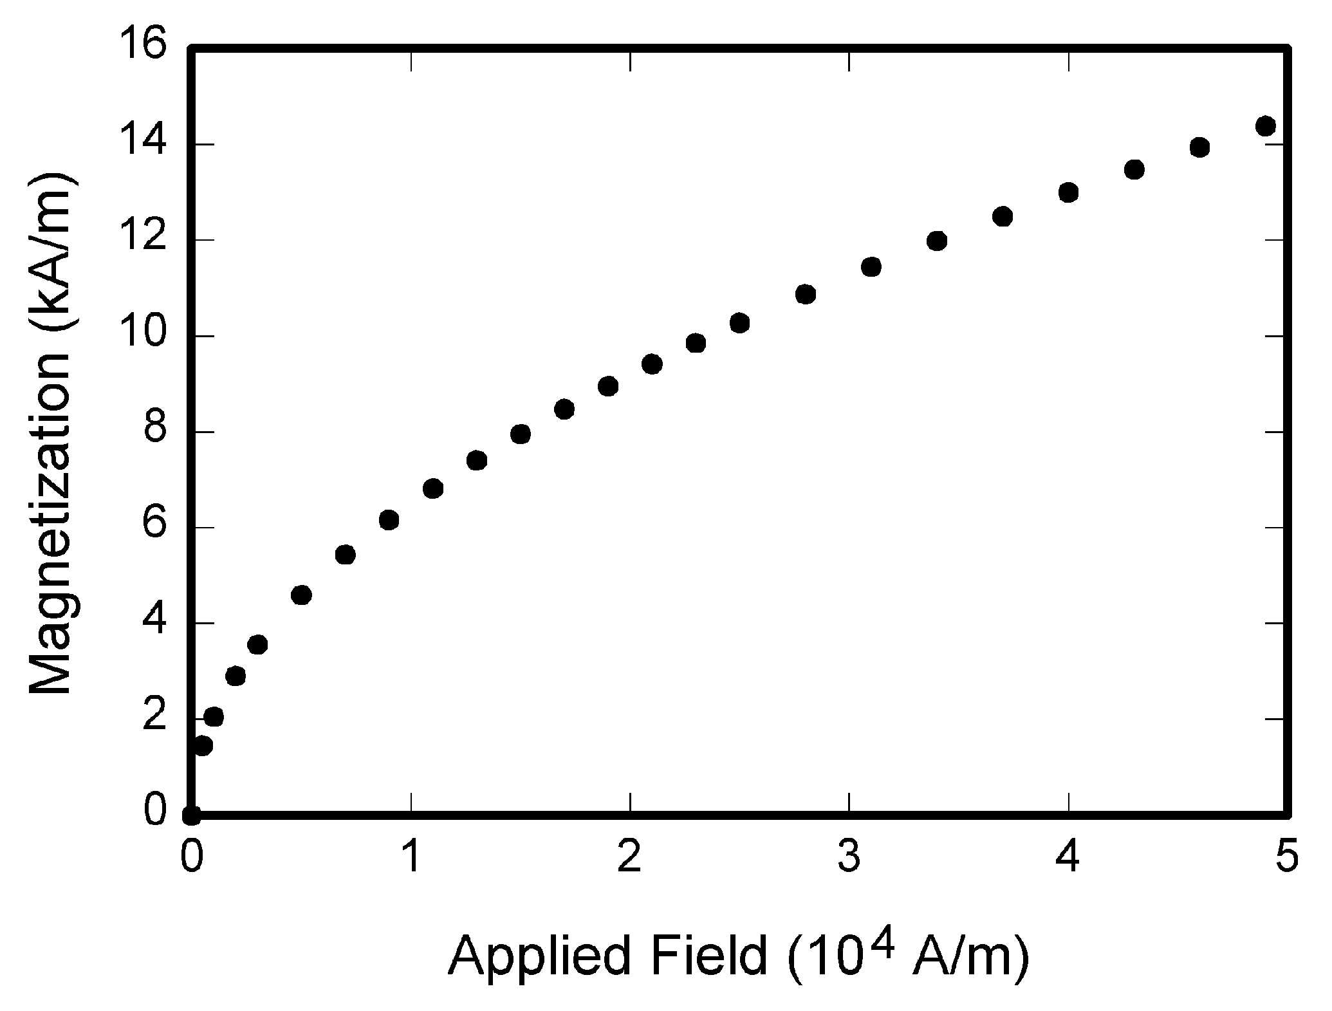
Fig. 1. Magnetization as a function of applied field. Note that “Fig.” is abbreviated. There is a period after the figure number, followed by two spaces. It is good practice to explain the significance of the figure in the caption.
If you decide to use color traces in your graphical data, be absolutely certain that there is no ambiguity about your graphical information when printed on a B&W printer.

Citing Previous Work
Number citations consecutively in square brackets [2]. The sentence punctuation follows the brackets [3]. Multiple references [3], [4] are each numbered with separate brackets [1]-[3]. When citing a section in a book, please give the relevant page numbers [3]. In sentences, refer simply to the reference number, as in [4]. Do not use “Ref. [4]” or “reference [4]” except at the beginning of a sentence: “Reference [4] shows ... .”
Note that IEEE referencing style is quite different from that used by most physics journals. Give all authors’ names; do not use “et al.” unless there are six authors or more. Use a space after authors’ initials. Papers that have not been published should be cited as “unpublished” [5]. Papers that have been submitted for publication should be cited as “submitted for publication” [6], [7]. Papers that have been accepted for publication but not yet assigned to an issue should be cited as “to be published” and include the journal abbreviation [8]. Please give affiliations and addresses for private communications [9].

Conclusion
A conclusion section is required. The conclusion may review the main points of the paper. It should not replicate the abstract. A conclusion might elaborate on the importance of the work or suggest applications and extensions.

Acknowledgment
The preferred spelling of the word “acknowledgment” in American English is without an “e” after the “g.” Use the singular heading even if you have many acknowledgments. Avoid expressions such as “One of us (S.B.A.) would like to thank ... .” Instead, write “S.B.A. thanks ... .”

References
- http://www.ieee.org/publications_standards/publications/authors/authors_journals.html
- G. Eason, B. Noble, and I. N. Sneddon, “On certain integrals of Lipschitz-Hankel type involving products of Bessel functions,” Phil. Trans. Roy. Soc. London, vol. A247, pp. 529-551, Apr. 1955.
- J. Clerk Maxwell, A Treatise on Electricity and Magnetism, 3rd ed., vol. 2. Oxford: Clarendon, 1892, pp. 68-73.
- I. S. Jacobs and C. P. Bean, “Fine particles, thin films and exchange anisotropy,” in Magnetism, vol. III, G. T. Rado and H. Suhl, Eds. New York: Academic, 1963, pp. 271-350.
- T. L. Gilbert, Formulation, Foundations and Applications of the Phenomenological Theory of Ferromagnetism, Ph.D. dissertation, Illinois Inst. Tech., Chicago, IL, 1956, unpublished.
- D. P. Arnold, “Review of superconducting radio-frequency cavities,” submitted for publication.
- L. Rossi, “Conductor choices for upgrades of CERN magnets,” IEEE Trans. Appl. Supercond. 23 submitted for publication.
- S. O. Demokritov and V. E. Demidov, “Micro-Brillouin light scattering spectroscopy of magnetic nanostructures,” IEEE Trans. Magn., to be published.
- C. J. Kaufman, Rocky Mountain Research Laboratories, Boulder, CO, private communication, 2004.
- Y. Yorozu, M. Hirano, K. Oka, and Y. Tagawa, “Electron spectroscopy studies on magneto-optical media and plastic substrate interface,” IEEE Transl. J. Magn. Jpn., vol. 2, pp. 740-741, August 1987 [Dig. 9th Annual Conf. Magn. Jpn., p. 301, 1982].

Submitted on January 1, 2018. (Write the date on which you submitted your paper for review.) This work was supported in part by the U.S. Department of Energy under Grant BS123456 (sponsor and financial support acknowledgment goes here).

